Python Training

Day 1 : 26-Feb-2024

Software :

System software

Application software

BCPL

Cobol

Fortan 77

Pascal

C 1970 : structure programming language

C+ Oops = C++ or C with classes

1980

1990 : Java as well as Python

2000 : .net : C#

2010 : JavaScript UI cloud technologies

2020 : AI, Machine learning : Python as well as R language

Web Service : Giving the service for web application when two application running using different technologies.

Micro service

Pip

Mvn

Npm

int a=10;

a=10;

int a=100;

a=”Steven”;

a=100;

a=”Ravi”;

a=True;

REPL Terminal :

Variable

int a=10; C or C++ or Java

a=20;

a = “Akash”;

var a=10; in JavaScript

let a:number =100; in typescript

a=10; in python

name=”Akash”;

result = True

a=False

differentTypeOfVariable.py

>>> id=100;

>>> name="Ravi";

>>> result = True;

>>> list =[10,20,30];

>>> set ={10,20,30};

>>> tuple=(10,20,30);

>>> dic = {id:100,name:"Ravi",age:21};

>>>print(type(id));

Multi variable declaration

>>> id,name,salary,result=100,"Steven",34000,True;

>>> print(id,name,salary,result);

100 Steven 34000 True

Same value storing in more than one variable

>>> a=b=c=100;

>>> print(a,b,c);

100 100 100

id() pre defined function which is use to find the reference code of that variable.

Mutable and immutable example

>>> empid=500;

>>> print(id(empid));

2784931300144

>>> empid=600;

>>> print(id(empid));

2784931314736

>>> ll=[100,200,300];

>>> print(ll);

[100, 200, 300]

>>> print(id(ll));

2784928387648

>>> print(ll[0]);

100

>>> ll[0]=1000;

>>> print(ll[0]);

1000

>>> print(id(ll));

2784928387648

ArithmeticOperator.py

a=10;

b=3;

res1 = a+b;

res2 = a-b;

res3 = a*b;

res4 = a/b;

res5 = a//b;

res6 = a**b;

res7 = a%b;

print(res1);

print(res2);

print(res3);

print(res4);

print(res5);

print(res6);

print(res7);

a=1+a;

a+=1;

in and is operator example

name="Welcome to python training";

print("in operator example");

print(name);

print("o" in name);

print("W" in name);

print("w" in name);

print("python" in name);

print("is operator example");

a=500;

b=500;

c=500;

print("a ",a);

print("b",b);

print("c",c);

print(id(a));

print(id(b));

print(id(c));

print(id(500));

print(a is b);

print(a is c);

a=600;

print("a ",a);

print(id(a));

if statement example

#a=-5;

#if a > 0 :

# print("number is +ve");

# print("Condition true");

#print("Normal Statement execute");

'''

a=10;

b=50;

if a > b:

print("a is largest");

else:

print("b is largest");

print("Normal Statement execute");

'''

sub1=80;

sub2=90;

sub3=90;

total = sub1+sub2+sub3;

avg = total/3;

if avg > 90:

print("A+");

elif avg >80:

print("A");

elif avg>70:

print("B");

else:

print("C");

print("done!");

looping.py

'''

for n in range(1,10):

print(n);

'''

'''

for n in range(1,10,2):

print(n);

'''

'''

list =[100,200,300,400,500];

for n in list:

print(n);

'''

'''

i=1;

n=10;

while i <= n:

print(i);

i=i+1;

print("while loop finish");

'''

x=0;

while True:

print(x);

x=x+1;

if(x==5):

break;

print("loop finish");

Day 2: 28-Feb-2024

input(): it is a pre defined function which help to take the value through console.

name=”Ravi Kumar”;

Printf(“your name is”,name);

Taking the value through keyword in Python

name=input(“Enter your name”);

print(“your name is “,name);

a=10;

a=20;

a=30;

if we want to store more than one value of same type or different types then in python we can use sequence data types.

list

set

dict

tuple

Stack

Queue

LinkedList

Tree

Map

Day 3 : 01-Feb-2024

Small application with basic python programming

Banking application

Dictionary, List, while, input, int, float, function etc.

1. Create account
2. Check balance
3. Withdraw
4. Deposit
5. Check account details

Python OOPs

OOPs using python

Object Oriented Programming

Object : object is any real world entity.

Property or state --🡪 have

Person

Behaviour 🡪 do/does

Bank

Animal

Car

Customer

Employee

Class : blue print of object or template of object or collection of object which have same property and behaviour or user defined data type which help to create the object.

ES5 javascript didn’t support class concept to create the object.

Using class we can implements objects.

Wheel, colour, price -🡪 has -🡪 variable or fields

car

start(), applied_gear(), moving(), stop()🡪 do the task

function or methods.

Constructor : constructor is a type of special function which help to create the memory.

Java : constructor have same name as class itself.

JavaScript : we need write function name with as constructor.

Python : python provided pre defined function with name as __init__(self): which behave like a constructor.

Encapsulation : binding or wrapping data (variables ) and function (code) in a single unit is known as encapsulation.

Example : Class itself by default follow Encapsulation rules.

If we want to make the instance variable as private we need to start with __ prefix as variable then it consider as private.

Inheritance : Inheritance is use to inherits the properties and behaviour of old class to new class. mainly it is use to do re-usability.

Once we do inheritance then with help of sub class object we can access super class property and behaviour. But with help of super class object we can access only its own property and behaviour.

Employee -🡪super class eid,name,salary

Manager 🡪 sub class employee numberofemp

Developer 🡪 sub class of employee projectname

ProjectManager 🡪 sub class Manager 🡪 clientInfo

Employee --- Manager 🡪 Single

Employee – Manager – ProjectManager – Multilevel

Employee – Manager and Developer – Hierarchical

Polymorphism : One name many forms or many implementation.

2 types

Compile time polymorphism : function overloading or operator overloading

Run time polymorphism : function overriding

Function overloading : the function have same name but different parameter list is known as function overloading.

Function overriding : the function have same name and a same function signature : means number of parameter and type of parameter must be same but different implementation.

Decorator or annotation

All decorator or annotation start with prefix @ followed by name. which provide extra behaviour to function or property.

Day4

Pre defined modules and user defined modules

Connection database mysql or postgres sql using python with ORM

ORM : AlchmeORM

We develop small application

Custom decorator or annotation

Day 5 and 6

Generic typing

Last two days

Python with Django with database we develop small application

Day 4 :

Modules : modules is a collection of function , classes , variable which have same names but different purpose.

Modules are divided into two types

1. User defined module
2. Pre defined modules

Exception Handling

Exception is a memory which generate which unexpected or abnormal condition occurs during the execution of a program.

Try : in this block we can write one or more than one line code which can generate the exception.

Except: this block execute if any exception generate. If there is not exception then this block doesn’t execute.

finally: this block execute if any exception generate or not.

To close the resources.

psycopg2: it is a third party modules which help to interact with postgres database to store, retrieve , update and delete the record from database.

pip is a tool kit which help to install required modules

pip install modulename

Day 5 : 6-Mar-2024

Core Python

Custom annotation

Web Application

Client server

http://[www.google.com](http://www.google.com) -🡪 URL

req(http/https)------🡪

Client Server

🡨----------Res(http/https) html or HTML5

Css or css3

JavaScript

It is use to do validation on client side.

Hyper text mark up language which help to create the web pages. Those web pages can be static as well as dynamic.

Html provided lot of tags. Html is not case sensitive.

Client side validation : username required, password required, phone number must be number type, emailid format etc.

Now a day we are doing the validation using JavaScript or HTML5 features.

We can do programming on web page without server.

Client side JavaScript do the validation which we can run on browser.

Html, css and JavaScript (Client side JavaScript)

We can’t store the data in file system, we can’t connect to database, we can achieve security etc.

We need server side technologies to create dynamic web page which can interact with file system or database and provide all features.

Java (JEE) or spring boot Asp.net

Php

Node JS (After node js we can say Java Script also known as client side as well as server side scripting language).

Python :

Html, css, JavaScript (validation) etc.

If we want to develop any web application using python their lot of open source framework present.

Freely available,

Framework work :

If we want to develop server side programming using Node JS. Node js provided one of module ie http module which help to create sever and as well as server side program. But if we develop web application using http module we need to write the code from beginning.

Node JS provided lot of external module ie express js. Express js is one of third party node js framework which help to develop web application very easily.

Java : JEE (Servlet or JSP) module are help to create web application.

Spring boot framework

Framework : framework provided lot of api in the form class or modules, function or methods which internally connected to each others. If we develop any application using framework 70 to 80% task taken care by framework. But framework is not a final product it is template or protocol. We need to take the help of framework to make the final product. All framework internally follow design pattern. Implementation of design pattern is taken care by framework.

Python web framework

Django and Flask

Flash is light weighted micro python framework. It is very simple, extensible web framework. React JS

Django is a full features framework best for scalable, features – reach project application. Angular

Django, is a high level framework written using python.

Django can be use to rapidly build complex database driven website.

Django provided URL routing

It provide template engines for html and css.

It provide in build database configuration by default Django use SQLite database.

Web security

Session management etc.

Django internally use MVT Design pattern or architecture.

Model : link with database to do the operation on table like insert, delete, and retrieve etc.

View : it is use to display the contents ie static or dynamic

Template : template is responsible, how to display the content on browser.

Custom annotation or decorator

Django Graph QL modules:

Django model limitation

Internalization who to handle the time zone.

Django

1. Can we use template
2. We can expose as rest api
3. Django Graph QL

If we use plain html we can use only static html contents.

All framework provide template engine do to dynamic work on web page.

Like Django html template

Spring boot : Thymeleaf View

Express JS Jade view engine for Express JS

Web Service : Giving the service for web application when both application running using different technologies.

Python Django

Amazon ----🡪 payment

Paypal Spring boot

Paytml Asp.net

Gpay php

Phone pay

Net banking

Java syntax Python syntax

XML / JSON

XML : eXtensible markup of language

JSON : JavaScript object notation

1. SOAP Web Service : Simple Object access protocol.

We can consume and produce the data only in the form of XML.

SOA (Service Oriented Architecture).

In this web service we can consume and produce data only in the form of xml.

1. Rest Full Web Service : We are expose our resources like Django, spring boot, asp.net as web service. So other technologies can consume those data. In Rest full web service we can consume and produce the data in any format like xml, json, text, html, media type etc.

So view can be java, python, asp.net, php, angular, react or any rest template etc.

Rest API has some limitation.

When ever any client or rest template send the request to rest full web service develop in any language like Java, Django, php

Django framework

Model : different types of Query, complex query, join, type of object etc.

Model migrations and advanced ways of tunning them?

Optimization of request bulk of data etc.

django "soft" constraints (ie constaints enforced by django, not the db)

validator

serializer for using in templates and rest apis

Django Framework Rest API (limitation of template)

Display form, images, table format etc.

Graph QL

Django

Before creating Django project we need to create python environment.

python -m venv myevn

in window user

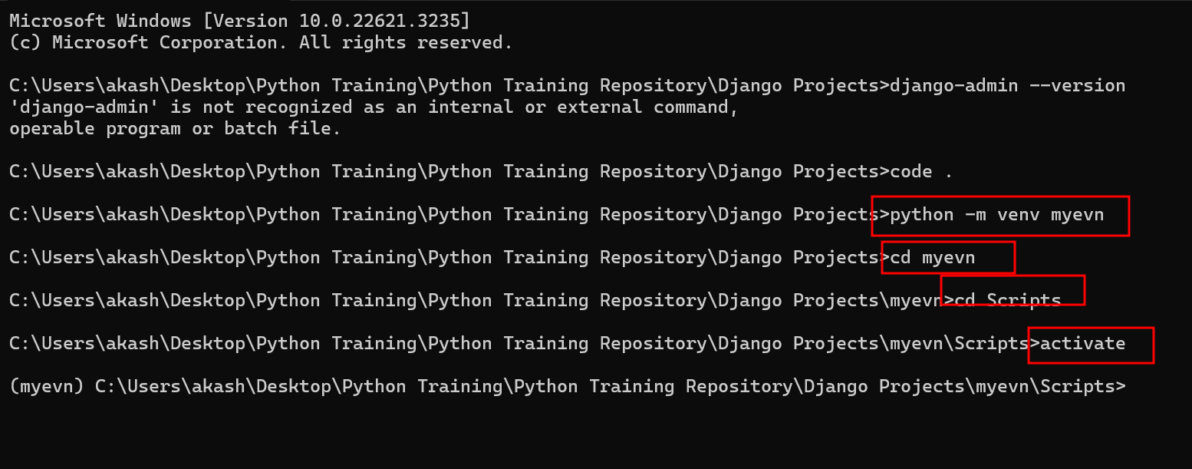

No window user

Unix or linux or mac

sudo pip install virtualenv

virtualevn venv -p python3

source venv/bin/activate

we need to install the Django using pip command

pip install django

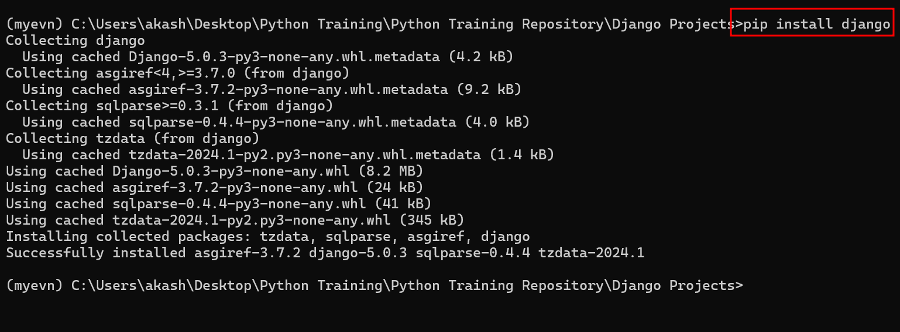

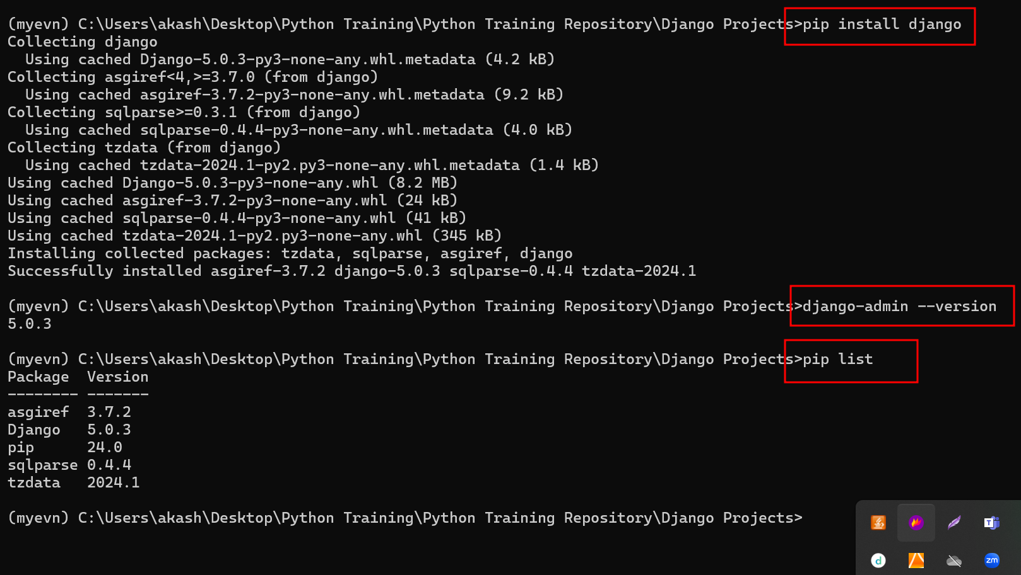

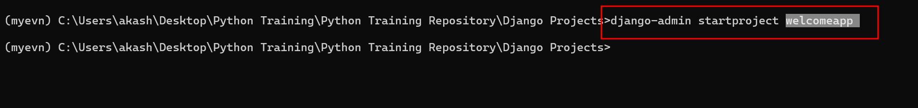

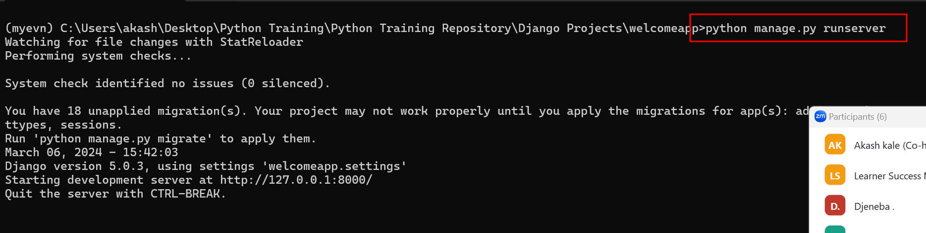

By default Django run on port number 8000

Running on different port number

python manage.py runserver 0.0.0.0:8181

setting.py : this file hold all setting details like app installed, database configuration, security related etc

Django internally provided the admin dashboard etc.

urls: This provide the routing information for the Django framework.

urlpatterns we can configure all custom routing paths details.

In Djago we need to create the views.py inside that file we can write more than one function which take request as a parameter which help to receive the request from client and base upon client request we can give response back to the clients.

Writing the response code or html code in external html page as template.

Day 6 : 11-Mar-2024

Project or application contains more than one modules

Login

Product

Customer

Feedback module

Payment module

django-admin startproject mysite

Django project by default provide SQLite data configuration

Django project by default provide admin dashboard.

Admin

User

Customer

Manager

By default Django provided admin related schema tables.

How to enable admin dashboard

python manage.py makemigration

base upon the model all those rules ready on application side ie SQL query.

python manage.py migrate : updated all model information on database ie SQLite

using python command we can enable admin dashboard account

python manage.py createsuperuser

to access admin dashboard we need to use the URL as

<http://localhost:8000/admin>

while developing the application we need to create the app (modules)

python manage.py startapp course course app

python manage.py startapp login

python manage.py startapp product

dynamic routing

in dynamic routing value can be int, string, slug type

display dynamic value on template page.

Inside this static folder we can add css, js, external js file, any static file.

Model :

In Django model is a type of python class which interact with database table.